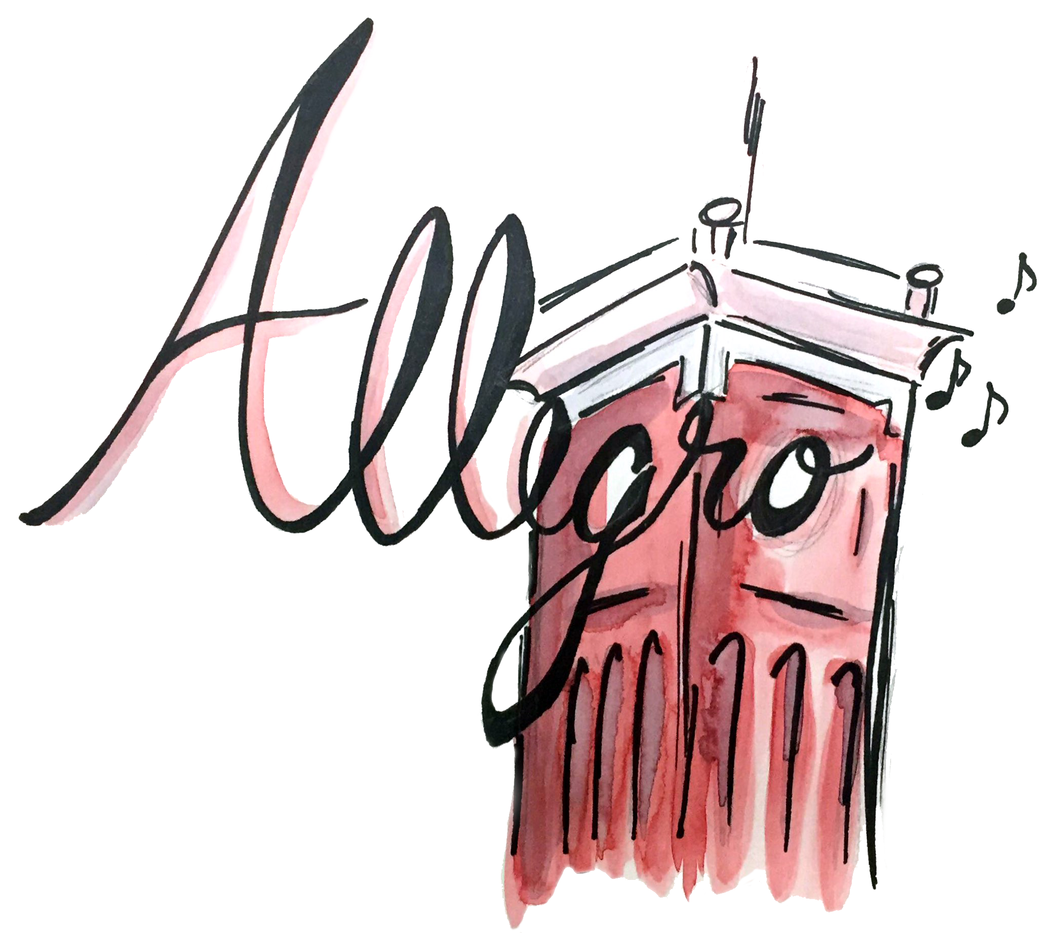
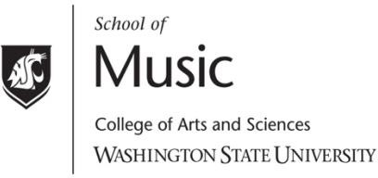

What is Allegro?

Allegro is an umbrella Registered Student Organization that represents all music student organizations at Washington State University. We aim to excite and inspire all students on the WSU campus with and through music. By partnering with student organizations, we provide funding to bring world-renowned guest artists to perform and work one-on-one with WSU students. In addition, Allegro offers travel scholarships to exceptional students and organizations traveling to competitions, festivals, conferences, and other music-related activities. Allegro receives generous funding from the Associated Students of Washington State University.
All RSOs are welcome to apply for Allegro funding. Applications are available in the Kimbrough Music Building office.

Allegro Concert Series

presents

Program Title Here

Performer Name, instrument

Month Day, Year
7:30pm
Venue

The Allegro Concert Series is brought to you by Allegro,
the Student Association for Music Advocacy.
Allegro Logo by Clare Sullivan

Biography of Artist

Program

Title Composer (birth-death)

Title Composer (birth-death)

Intermission

Title Composer (birth-death)

Title Composer (birth-death)

Title Composer (birth-death)

Title Composer (birth-death)

The use of recording devices or photographic equipment is strictly prohibited without permission from the School of Music. Please turn off cell phones and electronic devices.

